**Digitaliseringsstyrelsen – edelivery**

**O0400 - Technical Infrastructure**

.

.

.

.

.

.

.

.

.

.

.

.

.

.

.

.

|  |  |
| --- | --- |
| **Version:** | 1.0 |
| **Status:** | Final |
| **Author:** | Netcompany |



**Document history**

|  |  |  |  |  |
| --- | --- | --- | --- | --- |
| Version | Date | Author | Status | Comments |
| 1.0 | 20-12-2019 |  | Final | Output from eDelivery pilot project |

Table of contents

1 Introduction 3

2 Physical runtime environment 3

2.1 Environment overview 3

2.2 Nonprod environment 4

3 Network 4

3.1 Network infrastructure 4

3.2 Network access 5

3.2.1 Firewall rules 5

3.3 X509 Certificates Domain names and IP Addresses 6

# Introduction

This document is part of the technical system documentation for the eDelivery pilot project. This document describes the technical infrastructure and aims to provide an overview of the solution provided by Netcompany. This document is written technically and is primarily targeted at the technical personnel who works with either hosting the solution or architects needing an overview of the solution.

# Physical runtime environment

This chapter describes the physical execution environment. The network infrastructure is described in more detail in later chapters.

## Environment overview

Due to the simplicity of eDelivery which is comprised of two applications – the Access Point and the Service Metadata Publisher, the project is using only one server. It is a Virtual Machine deployed on Netcompany’s physical server. It is a NONPROD environment as the project is a prototype.

|  |  |
| --- | --- |
| Feature |  |
| Server Hostname | dig-dpn-app01 |
| Hosted by | Netcompany |
| Type of environment | NONPROD |
| Server type | Virtual Machine |
| Server function | Development server |
| FQDN | dig-dpn-app01.nonp.dp.dig.nchosting.dk |
| Internal IP | 10.1.77.50 |
| External IP | 212.98.96.26 |
| OS | Oracle Linux 7 |
| Installed software | Docker, Docker-compose, git |
| CPU | 2 |
| RAM | 4GB |
| Disk space | Root 32GB; Data 50GB |
| Network place | nonp-dmz |
| Physical place | ncop-vmclu-linux-prod-22h-01 |

Figure 1: Production Environment

## Nonprod environment

Environment diagram:

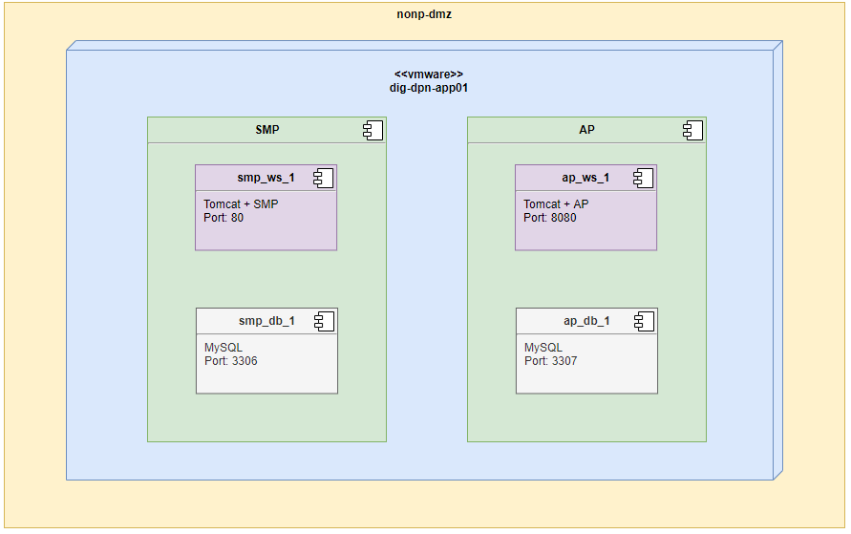

Figure 1. Environment diagram

* Virtual Machine is installed in the nonp-dmz space
* Within the Virtual Machine dig-dpn-app01 two applications are installed – SMP (Service Metadata Publisher) and AP (Access Point).
* Each of those applications is comprised of two containers, one with Tomcat and the application itself and second with a Mysql Database server

# Network

This section describes important details about the network used for eDelivery – e.g. IP segmentation, firewall openings and public www-addresses.

## Network infrastructure

The entire network for eDelivery has the IP scope 10.1.77.50

## Network access

This section describes network access in the infrastructure i.e. firewall rules that are used for making IP restrictions to the infrastructure.

### Firewall rules

Firewall rules:

|  |  |  |  |  |  |
| --- | --- | --- | --- | --- | --- |
| **FROM** | **TO** | **FQDN** | **IP** | **PORT** | **Protocol** |
| eDelivery server | eDelivery EU service | [acc.edelivery.tech.ec.europa.eu/](https://acc.edelivery.tech.ec.europa.eu/) |  | 443 | HTTPS |
| eDelivery server | eDelivery EU service | [edelivery.tech.ec.europa.eu/](https://edelivery.tech.ec.europa.eu/) |  | 443 | HTTPS |
| eDelivery server | Bitbucket | [bitbucket.org](https://bitbucket.org/) |  | 443 | HTTPS |
| eDelivery server | Docker hub | [hub.docker.com](https://hub.docker.com/) |  | 443 | HTTPS |
| NC internal network | eDelivery server |  | 10.1.77.50 | 22 | SSH |
| Public network | eDelivery server |  | 10.1.77.50 | 80 | HTTP |
| Public network | eDelivery server |  | 10.1.77.50 | 443 | HTTPS |
| Public network | eDelivery server |  | 10.1.77.50 | 8080 | HTTP |
| Public network | eDelivery server |  | 10.1.77.50 | 8081 | HTTP |

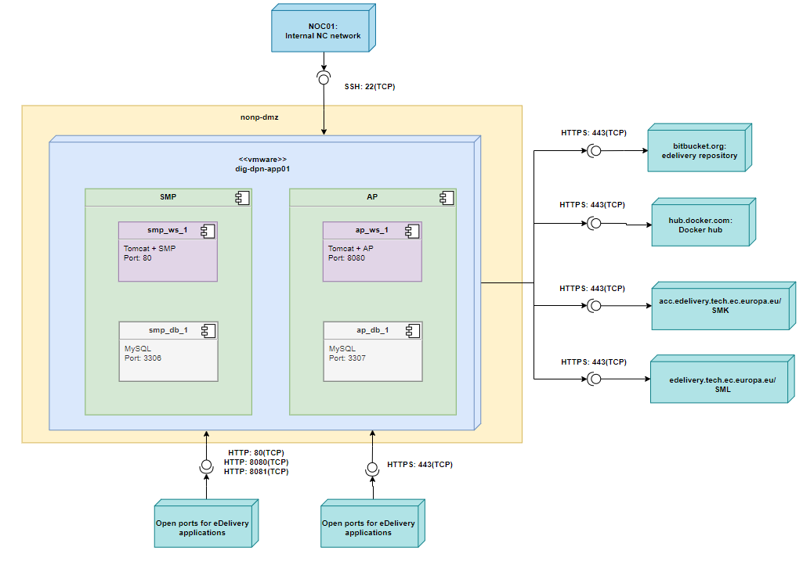

Figure 2. Firewall openings diagram

## X509 Certificates Domain names and IP Addresses

This section describes the x509 certificates, (sub) domain names and public IP addresses that are used in the solution.

The table below lists all the sub domains used for the solution:

|  |  |  |  |
| --- | --- | --- | --- |
| Domain | Environment | Public IP | Description |
| dk.acc.edelivery.tech.ec.europa.eu | NONPROD | 212.98.96.26 | Used for accessing Service Metadata Publisher |
| dk.acc.edelivery.tech.ec.europa.eu:8080/domibus | NONPROD | 212.98.96.26:8080 | Used for accessing Access Point |